**Senior Software Report 2**

Team 1 – TUtor Me

Bonnie Brent, Danny Saltus, James Seales, William Shepherd, Kenny Wong

Database Schema and Use Case Diagram

# I. Web Services

* Our application does require the use of web services in the following ways:
  + All Tutor and Event data will be stored in the database and therefore require constant communication with the web service in order for our application to remain useful and up to date
  + The database will also host the academic calendar information at this time

(We are hoping to find some kind of solution that will pull the academic calendar from an existing Trinity Website and therefore eliminate the need for an administrator to enter new academic calendar info)

## Database Schema

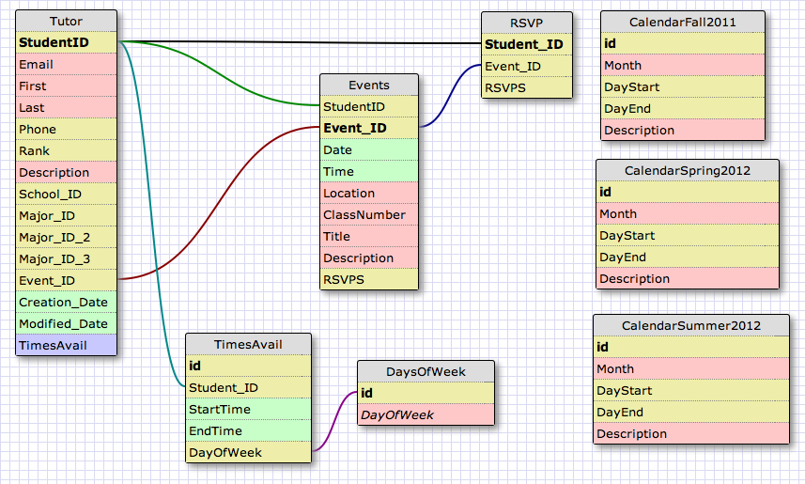

# II. UML Modifications

* No UML modifications with the exception of the attached Use-Case Diagrams for both user and administrator.

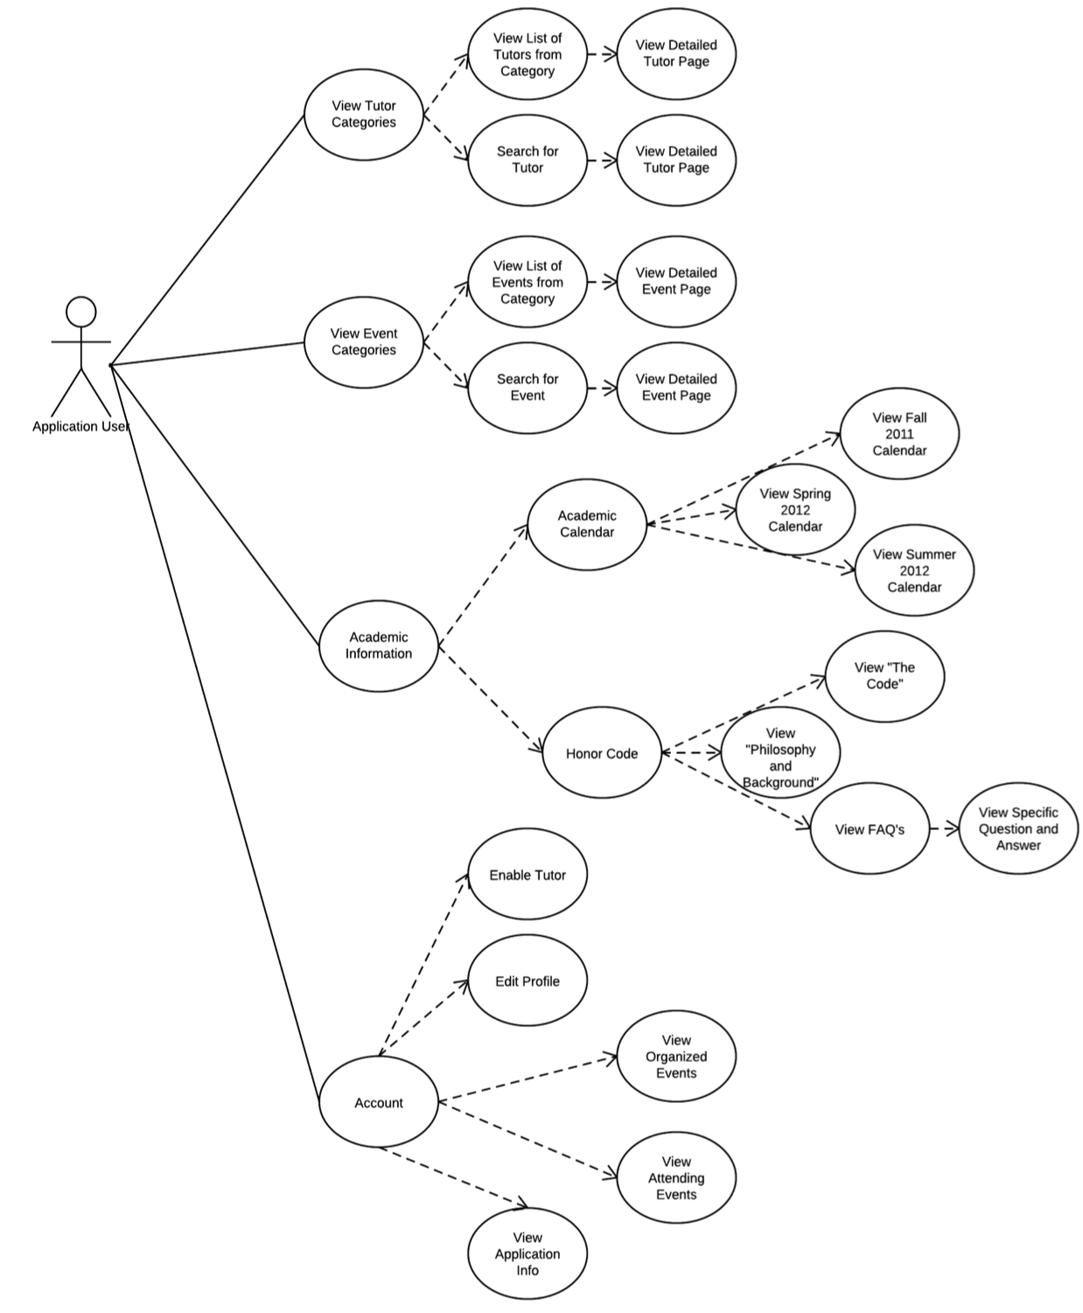

## Administrator Use-Case Diagram

# 

# III. Rationale

* Described above.